COMP.5203

Professional Practice

Semester 2, 2024

Website Design

30094916

Oliver Nicholls

Date: 04/11/2024

Contents

Initial Website Ideas 2

Page 1: Interactive Table Page 3

Page 2: Interactive Map Page 4

Page 3: Videos Page 5

Page 4: Resources 5

# Initial Website Ideas

After the completion of the planning stage, I had a ruff layout and design philosophy to follow when creating my website.

I needed 4 pages in total.

The first being a brief intro video and text followed by an interactive table with New Zealand’s top 10 highest Co2 emission producers in order from highest to lowest.

The second being the most complex page with an interactive map, the user can click on a specific region of New Zealand and will be shown information relating to that region.

The third being a simple video show case that will inform the user on where Co2 comes from and what New Zealand is doing to reduce emissions. The videos must be displayed 1 at a time with some way of cycling through them.

The last page will be a collection of all the references I used to create the website and a short section about the company OliKo as well as the projects title and my name.

# Page 1: Interactive Table Page

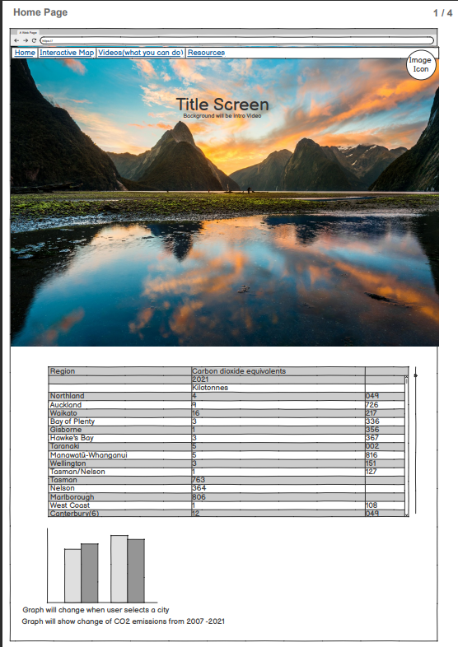I started on designing the Nav bar and footer before doing anything else, I wanted to create a simple and easy to read Nav bar that included the company’s logo which came together quickly but it looked quite bland so I included a image of some waves to bring some visual stimuli to the Nav bar as well, this complicated the design as I struggled to get everything to line up initially but after messing it for a while I got the logo to overlap the background image and everything was spaced out well.

For the footer I copied the same design from my previous website and change the text as well as the size and opacity.

After the nav and footer where complete I copied them to the other 4 pages and began work on the bulk of page 1.

Page 1 started off with a large title and a visually interesting video about global warming, underneath is a short description of what the website is, why it was created and what it does. Next to this is a pie chart I took from a New Zealand energy commissions report about where New Zealand’s energy comes from, these are placed side by side in a flexbox to make it easier for the user to read and enhance user flow.

The last part of page 1 was by far the most complex and required me to try numerous methods before it worked the way I wanted it to work. The idea was simple, make a table of NZ regions that when clicked on would update a text box below with a description of the region and an image of where it was, I practice this was more difficult than I had anticipated.

After doing some googling, I discovered something called jQuery which is an online API of sorts which has lots of preset tables I could pull from but after struggling for hours to and failing I gave up on this method and looked for a simpler method.

I found a method that would work in a stack overflow form using the inbuilt <table> method. This was a lot simpler than jQuery and worked flawlessly, although it was a bit unintuitive at first. I can define the headings with <th>, the rows with <tr> and the actual information I want to display goes in the <td> tags. After the information was in place I assigned an ID tag and onclick function to each row and jumped into java script to make the responsive features work.

I haven’t used java much before, so I used some guides and stack overflow forms to get the box below to update with information about the region and an image of the region when the user clicked on it. I got the region images from a website called free world images.

Overall, I am very happy with how page 1 turned out, it definitely took the longest to make as I messed around with jQuery for too long, but the final table works just as intended and is very easy to use.

# Page 2: Interactive Map Page

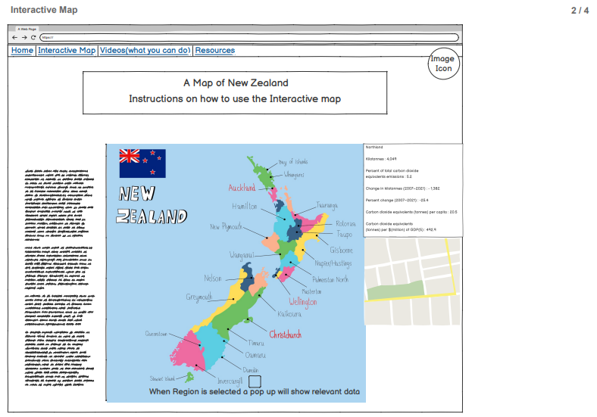This Page was going to be my hardest, but I believe the final result meets every standard is set.

When starting this page, I had no idea how to make or use interactive maps, I spent a lot of time googling different methods but was weary of over complicated ones as I didn’t want to waste time like I did with jQuery.

I eventually found a method I thought would work perfectly and was not to complicated, using SVG files u can import maps which already have had the region boundaries defined. I followed a guide called “**How to Make a Clickable SVG Map with HTML and CSS”**, which made it much easier to create my version of the Map.

I downloaded a premade SVG file of New Zealand of off google and followed the guide, ignoring bits I didn’t need and changing things around when needed.

The guide doesn’t show how to make the SVG map clickable but because each region can be assigned it own unique ID tag and the SVG file uses a different key for each region I can make a big dictionary with all the information relevant to the region in java script and then write a function that takes that key when the user clicks on a region and outputs the relevant data into a flexbox along with some graphs I made in excel.

Each graph uses data from the same Greenpeace report as used in the table of page 1. I took screenshots of these graphs and saved them as .jpg files

The Java script function took many attempts to get working but with the help of stack overflow and by copying parts from the previous function I got it fully functional. It waits until a user clicks on a region then takes the ID name and region key to find the relevant information in the massive dictionary and then updates the image and text on the output flexbox.

Overall, I’m very happy with how this page turned out, it looks clean and works without fail. The code for this is quite messy and most of it is one giant dictionary and one function. the layout of this page follows the ruff layouts close enough, but some layout changes have been made to keep the page from being overcrowded with information.

One problem I haven’t been able to resolve is the SVG maps layout, New Zealand is pushed up against the far left instead of being centred, fixing this would require me to switch the SVG file and re format a lot of code. The SVG file cannot be altered with my current level of understanding, I could switch the image out, but I haven’t found a suitable replacement and changing the file this late in development would require a lot of work for not much gain.

# Page 3: Videos Page

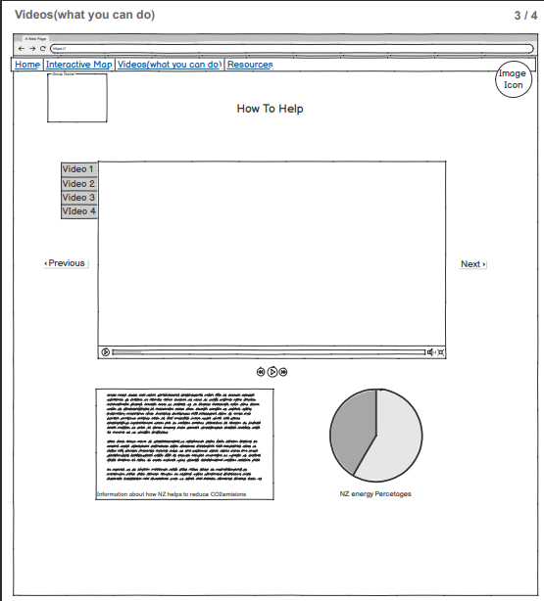page 3 was quite a simple page in comparison to the previous 2, my main struggle going in was getting the next and back buttons to switch out the videos but using the knowledge I had gained from my previous java script functions, I simple stuck all videos through a list and then made a function that increments by 1 through the list if the next button is pressed and another function that increments backwards by 1 through the list if the back button is pressed.

I also had to put in an if statement into each function that sets the index number back to 0 if the user tries to go outside the lists range. e.g. if the last video is playing and the user clicks next the first video is played or if the first video is playing and the user click the back button the last video is played. This simulates a seamless loop of videos.

Above the videos is a short description of what the user can expect to see in the videos and some brief instructions.

Below the videos is the title of the currently playing video which updates with the video and the back and next buttons.

This page was a good break from the previous 2 pages complexity. Overall, I’m satisfied with how this page turned out although the page is rather bland in comparison to other pages and doesn’t contain a lot of information other than the videos.

# Page 4: Resources

Page 4 was the last page I worked on and took the least amount of time to make. I had no issues getting the layout to display correctly as it only contained to flex boxes.

On the left is the links to research material and data used for the website as well as links to all image sources, video sources and links to websites and forms I used to help me code this website.

On the right is an image of the company’s logo as well as a short description of the company’s goals below the logo image. Underneath is the course details, my student ID and name.

Page 4 was very easy to set up and required no java script, although the page is rather bland it is only needed to display the resources that went into this website and a brief description OliKo, thus it has no need to be flashy or overly exciting.